Contents

Installation of IntelliJ IDEA 1

Selenium configuration and references. 2

## 

## Installation of IntelliJ IDEA

Download IntelliJ IDEA from <https://www.jetbrains.com/idea/download/#section=windows>

Note: *Please select the installer based on your environment. Here I select based on my environment – “Windows”*

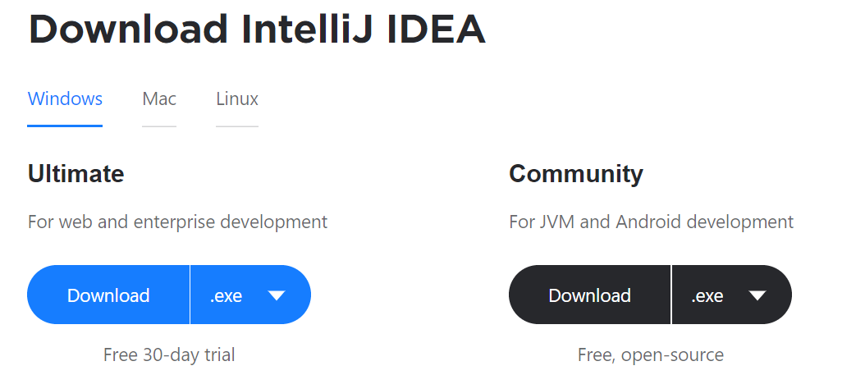

Make sure Java is configured like below.

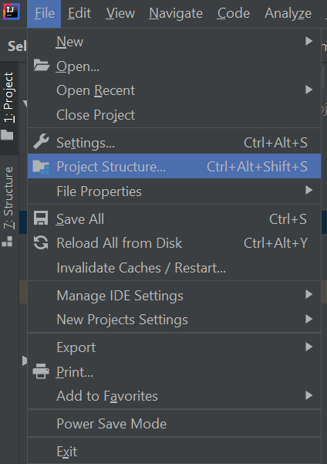 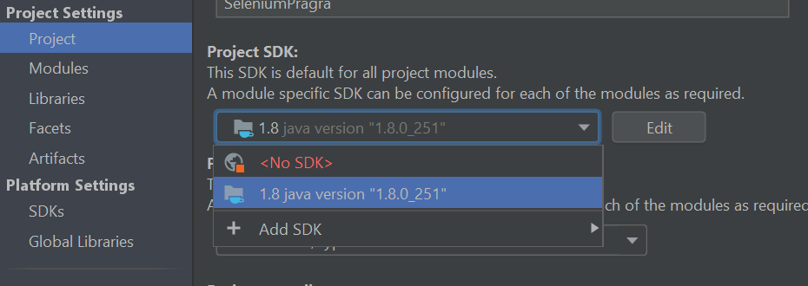

When you are setup like above, you are “All Set to Go”.

## Selenium configuration and references.

Here in this training we configure Selenium through “Maven”.

*File -> New -> Project -> Maven -> Next -> “Select a Project Name” -> Finish*

When the new project is created, Update the pom.xml with below dependency.

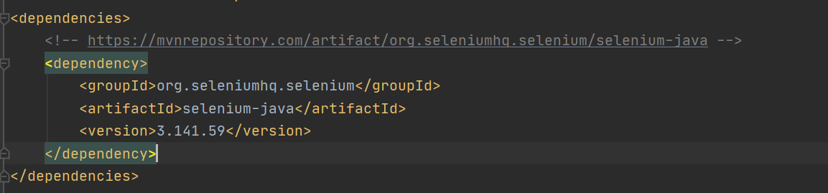

Once the dependency is updated, right click on “pom.xml” and Reimport.

“*All the selenium external jars will be downloaded and configured*”

Please refer to the sample video from the repository for setting this up.